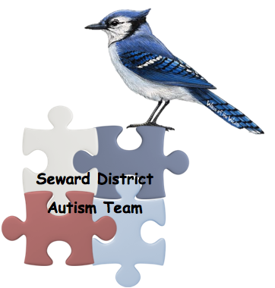

**Behavior Tips and Tricks**

**Presented by:**

**the Seward District Autism Team**

Are you tired of trying to discipline your child only to have them do the same thing again 5 minutes later? Does your child act like an angel in public but melts down the minute you get home? Do you want more information about managing your child’s behaviors? If so, this parent information session might be just what you need.

At this parent information session participants will learn:

* What disruptive behavior is
* How to manage behaviors
* Behavioral triggers
* How to reinforce the behaviors you want to see
* Logical consequences
* How to ignore behaviors
* How to use Time Out in an effective manner

If this sounds appealing, join us!

**When:** December 2nd from 6:30 to 7:30

**Where:** Seward Elementary, 200 East Pinewood Ave. Room 110

**Other information:** The Seward High School Family and Consumer Science students will provide childcare at no cost. Please contact Connie Biaggio or Beth Seegebarth to sign up for childcare. Email: [connie.biaggio@sewardschools.org](mailto:connie.biaggio@sewardschools.org) or call 402-643-2968 by 4pm on December 1st.