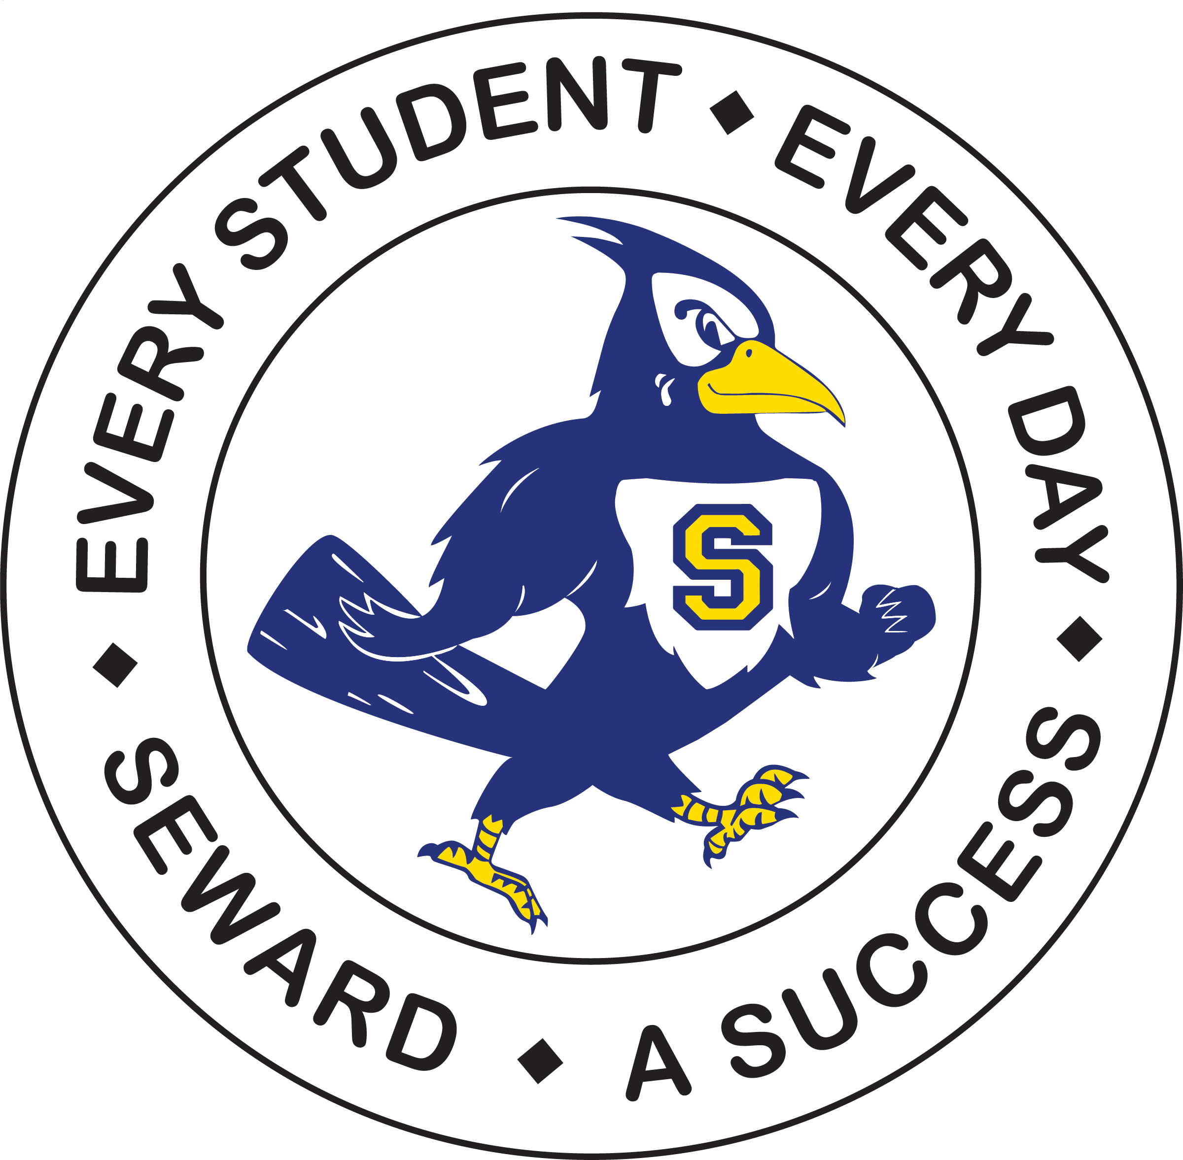

Mission: The school district of Seward-where every student, every day is a success-affirms that all students will have the skills to become productive and contributing members of a global community. In cooperation with family and community members, the district is committed to the development of each student academically, emotionally, socially, and physically.

2019-2020 Special Services Annual Report

By Connie Biaggio, Director of Special Services
June 1st, 2020

During the academic year of 2019-2020, Seward Schools provided quality special services to 799 students in need through utilization of Special Education programming, 504 accommodation plans, English Language Learner services, Title One instructional programming, Six Pence services, and High Ability Learner activities. Within these six programs, students age’s birth to 21 years received specialized help with their specific academic needs. This number includes students with special needs who attend area parochial schools.

*Special Education Programming*

Special education staff members provided individualized services to a total of 403 students over this past year. Of those students, 30 were students who moved into our District with previous special education verification. In addition, 83 new referrals for initial special education evaluation were received for students’ ages’ birth through 21years. 73% of those students that were referred qualified for some form of special education programming. The individual programming that was then designed for each student may have included one or more of the following services: resource instruction, speech therapy, occupational therapy, physical therapy, vision and /or hearing instructor consultation and vocational transition coordination. It should be noted that due to Covid-19 testing for 2 school aged students and 17 preschool aged students had to be placed on hold.

*Special Education Targeted Improvement Plan*

The concept of the Targeted Improvement Plan or TIP is that special education program improvement should be tied to a district's overall school improvement format and in fact it should follow the five year timeline of the regular school improvement plan.

To this end Seward Public Schools has had two goals that are being monitored:
- 70% of Seward Public Schools special education students will make individual growth in reading on standardized assessments in the next four years
- 70% of Seward Public Schools special education students will make individual growth in math on standardized assessments in the next four years.

The Nebraska Department of Education has asked that we focus on just the reading goal for reporting purposes. That does not mean mathematics has been ignored as data has continued to be reviewed in district.

During the academic year of 2019-2020, a formal annual TIP report for NDE was completed by December 1st. This formal TIP annual report provided data and documentation related to the set reading goal, which included intervention fidelity check documentation, and student growth data indicated from NWEA testing. In early February, the District received notification from NDE of successful progress on our TIP.

Additionally, a PEaK (Promoting Engagement and Knowledge Project) grant was applied for and received from NDE for the amount of $10,845 to support efforts in striving to reach our TIP goal. The funds were utilized across the 2019-2020 school year for Social Emotional Learning trainings for all teachers via a presentation and two webinars provided by Dominque Smith, a national speaker on SEL, and support for the development of an MTSS (Multi Tiered System of Support) framework for Seward Schools. The MTSS portion of the funds provided training opportunities for members of the District wide MTSS committee. Both the Social Emotional Learning trainings and the MTSS work directly connect to our TIP goal and the District’s new strategic plan.

*Title One*

The goal of Title One programming in Seward Schools is to aid students who have difficulties with early primary reading development. Seward utilizes the traditional format for Title One instruction that addresses specific reading curriculum standards through small group instruction, practice and direct coordination with the regular classroom goals.

Funding for Title One services in Seward Schools is based on Free and Reduced School Lunch funds. Of the funds that are then received by the district, part goes to provide special reading instruction to three qualified parochial schools within our district area and our public elementary school. A piece of the funding also goes to a tutoring program for students within any group home setting specifically located within our district boundaries. During the past year a total of 102 students received specialized reading instruction through Title One programs.

*English Language Learners*

Seward Public Schools English Language Learners (ELL) program strives to meet the following goals:
*Establish that the education of ELL students is the responsibility of every teacher and administrator in the district
*Promote the academic achievement of ELL students *Enable ELL students to develop academic skills while learning English
*Provide for linguistic, academic, and affective needs of ELL students
*Provide ELL students with instruction necessary to allow them to progress through school at a rate commensurate with their native-English -speaking peers
*Coordinate the ELL program with the regular education program to ensure ELL students receive subject matter content as quickly as possible.

During the 2018-2019 school year, 5 students were formally identified per Nebraska Department of Education and No Child Left Behind regulations as English Language Learners.
5 additional students who have met exit criteria from their spring 2017, 2018, or 2019 ELPA-21 scores were monitored for growth across the 2019-2020 school year.

Those students who qualified for ELL programming are served in an alternative language program. Progress of those qualified students was assessed during the spring of 2019. Students who performed at a level comparable to non-ELL peers and are able to participate meaningfully in content areas based on these testing results will then be exited from the program. Students who are exited receive monitoring of their academic levels across four consecutive years of education following their year of exit. Any of the exited students who do not exhibit passing grades each quarter will then be considered for re-entry into the ELL program at that time. In May of 2020 the sixth annual district wide review of the ELL program was completed and placed on file per a Nebraska Department of Education Rule 15 regulation.

*High Ability Learner Programming*

The High Ability Learner Program Philosophy at Seward Schools is:
“We believe that children learn best when they are challenged and nurtured in methods that are commensurate with the levels of their abilities. It is the responsibility of the school to facilitate and/or provide opportunities to meet the needs of each of our students.”

A District-wide Leadership Team facilitates identification and implementation of the High Ability Learner program for the High Ability Learner. The Leadership Team consists of Elementary, Middle School and High School Teachers and the Special Services Director. The identification process includes multiple criteria in an effort to be inclusive rather than exclusive. The process is based on a combination of standardized instruments and non –standardized means and criteria. The Leadership Team worked through out the 2015-2016 school year to devise a new matrix system of points and qualifying cutoff numbers for all nominees. The team also determined that given the timing of the District NWEA testing and Nebraska State testing timelines that nominations for the High Ability Learner Program will be received in October only of each academic year. The new Rubric was applied to nominees for the first time during the 2016-2017 school year and use was continued during the 2019-2020 school year. Following the receipt of the nominations, the Leadership Team reviews all supporting materials for possible identification.

Currently the School District of Seward has 130 identified High Ability Learners in Grades 3-12. Curriculum for identified High Ability Learner students incorporates the core curriculum of the classroom with a differentiated curriculum. The student, parent(s) and teacher(s) for each identified learner, beginning at Grade 3, may create an individual education program. Prior to Grade 3, High Ability Learners are nurtured through differentiated curriculum and enrichment activities. The program seeks to achieve excellence by building upon the strengths and the interests of the students and by focusing on the delivery of five major services to the students:

*Identifying student’s academic strengths, interests and
learning styles
*Curriculum compacting
*General exploratory activities
*Group activities that develop high level of thinking and
affective processes

*Individual and small group investigation of real
problems.

During the 2018-2019 school year several recommended changes were implemented based on input from a district wide team that reviewed the district’s HAL program during the summer of 2018. The three recommendations included: 1) holding a HAL Parent meeting annually, 2) development and utilization of grade level/subject specific High Ability Learner Plans (HALP) for each identified HAL student, and 3) administering the CoGat abilities test to the top 10 % of all second graders as a means to seek earlier identification of HAL students prior to the beginning of third grade.
All of these recommendations were successfully implemented this year.

*Seward County Sixpence Program*

The Seward County Sixpence Program is in it’s fifth year this year thanks to a continuation grant that was written collaboratively by Seward, Milford and Centennial Schools in conjunction with Blue Valley Community Action. The program is designed to provide parents and soon to be parents, the opportunity to bond and develop strong relationships with their children through age three. Parents learn to be their child’s first teacher, promote learning within the home environment, and encourage and support curiosity within the child’s play. Two full time Sixpence Home Interventionist’s serve as resource personnel for support throughout families’ participation period in the program.

Sixpence serves families who live in Seward, Milford, and Centennial Public School Districts, families who have a child birth to 3 years of age or who are pregnant, families whose income would qualify for Free or Reduced Lunch Program, families who have infants who were born prematurely or at a low birth weight, families whose primary language is not English, teen parents, and parents with no high school diploma or GED.

At this time 20 children from the Seward School District are involved in the Sixpence Program.
5 more children are participating from the Milford and Centennial School Districts. There is a current waiting list of 8 families for this program. The goal of the grant was to reach 24 children across the county and it is great to have surpassed that goal each of the past four years. If you are interested in learning more about the Sixpence program just contact the Elementary School office at 402-643-2968 and ask to be transferred to the Special Services Office.

